KATOOL KT-YA260 Sheet Metal Quick Repair Pull Tower Instruction Manual
Product Introduction : Primary Advantages
The automotive sheet metal quick repair pull tower, known for its low investment cost, ease of operation, speed, and space-saving features, is now widely used in countries such as Europe, America, Japan, and Korea. It is well-received in car 4S shops, quick repair shops, training institutions, schools, etc.
Installation Advantages
This product requires no embedding, only a standard workstation for installation. A concrete thickness of only 200mm is sufficient to easily secure the ground anchors. The standard configuration includes four round disk floating surface ground anchors fixed on a 20cm cement concrete ground. The number of ground anchors can be increased as per customer demand, facilitating vehicle repair needs.
Usage Advantages
Vehicles do not require a specialized calibration frame; the operation is simple, quick, and convenient. The calibration station can also be used for parking vehicles, dismantling, painting, etc., saving space. It is safe, convenient, fast, low-cost, and saves time and effort.
Product Parameters
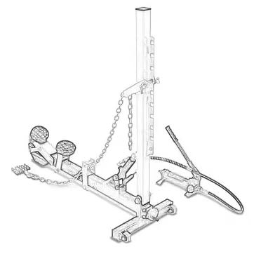
（Section I）
Equipment Name: Automotive Sheet Metal Quick Repair Pull Tower
Equipment Model: Hydraulic Top Rod Pull Tower
Maximum Allowable Traction Force: 1000KG
Applicable Vehicle Types: Sedans/SUVs/Minivans, etc.
Manufacturer: JiangSu. Pioneer Limited Company

Product Overview
This product is a three-in-one repair pull tower for auto body sheet metal repair, primarily used for the repair of damages located at various parts of the car body such as the front and rear fenders, lower door sills, and left and right doors. During the sheet metal repair process, it outputs a pulling force ranging from 0 to 1000KG, allowing for adjustments in height, angle, and position. This facilitates more efficient car body repair, enhancing repair quality, and reducing operation time, hence saving time, effort, and money. It is safe, convenient, and quick to use with a scientifically rational and standard structure that is easy to understand and operate.
Name | Quantity | Unit | Specification | Remark
Pull tower (including guide ring) | 1 | set
Ground anchor (including 4 expansion bolts) | 4（standard） |  |  | Optional
Chain | 1 | piece | 1-ton bearing capacity
Hydraulic jack | 1 | set | 10 tons
Repair kit | 1 | set
Single-eye stainless steel 304 pull claw | 1 | set | 6 claws
Single-eye stainless steel 304 pull claw | 1 | set | 8 claws | Optional
Tightener with 1.5m 6mm chain | 1 | set |  | Optional
Skirt support rod(including regulator) | 1 | set
Tire pressure plate (front, side) | 1 | set
Safety rope 1.5m | 1 | set
Product Features:
1.The product is welded from 60x60x6mm thick-walled seamless rectangular pipes, boasting high strength and capable of withstanding a maximum pulling force of 1000kg.
2.It serves as a power output device during the sheet metal stretching process.
3.Before using the product, customers need to install ground anchor seats on the sheet metal station.
4.Usage: Move the product to the appropriate position. Connect one end of the stretching chain to the tower column guide ring, and the other end to the car body (through sheet metal fixtures, pull claws). In the reverse direction, secure one end of the chain to the column (opposite to the stretching chain direction), and the other end to the short chain on the ground anchor seat, forming a counterforce.
5.During the stretching process, the pull tower is not subjected to bending forces, ensuring a longer lifespan.
Working Principle：
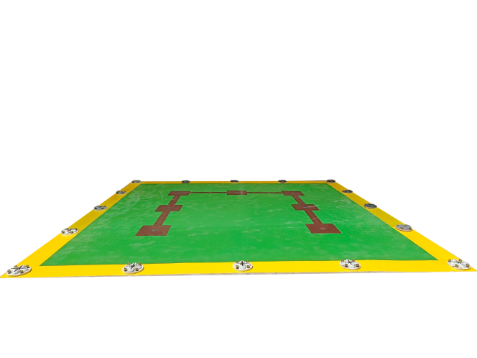
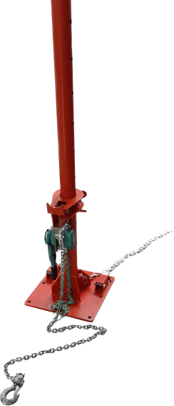
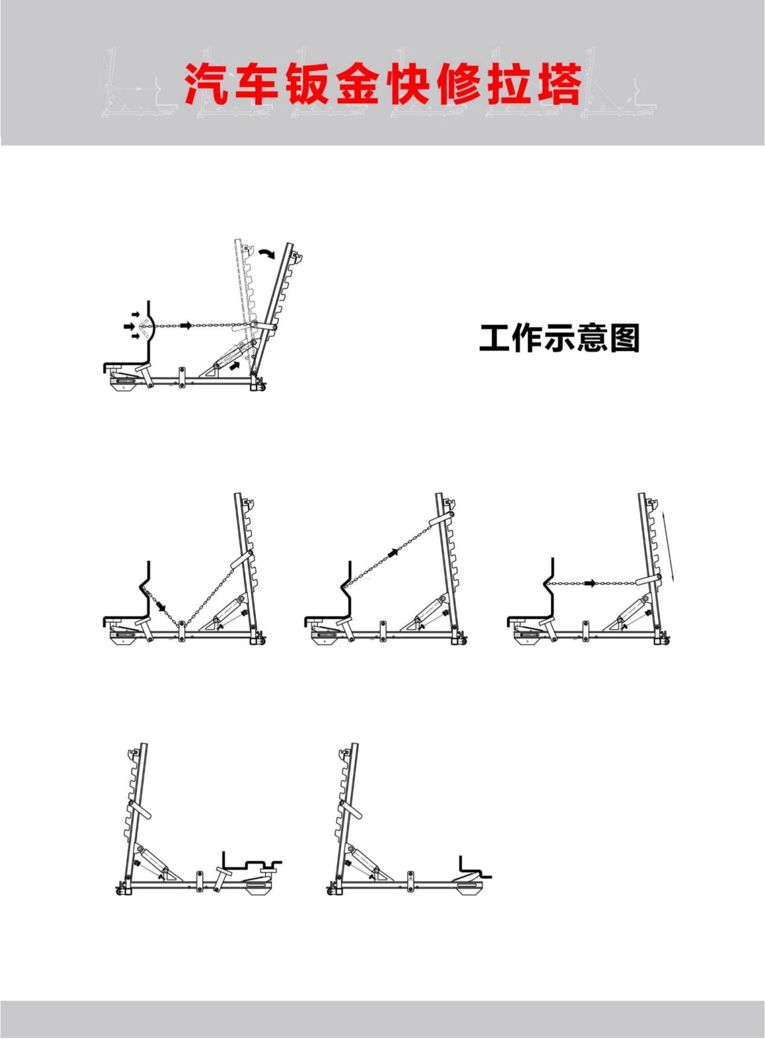

（Section II）
Device Name: Quick Repair Pull Tower for Auto Sheet Metal
Device Model: Hand-levered Chain Pull Tower
Maximum Allowed Pull Force: 3000KG
Applicable Vehicles: Sedans/SUVs/Minivans, etc
Manufacturer: Jiangsu Pioneer Sheet Metal.Ltd.

Product Overview
This product is a three-in-one repair pull tower for auto body sheet metal repairs, suitable for full-body stretching and repairs. It can exert a pull force ranging from 0 to 3000KG during the sheet metal repair process, with adjustable height, angle, and position, facilitating more efficient repairs, reducing the repair time, and improving the quality of the repairs.
Name | Quantity | Unit | Specification | Remarks
Pull Tower (includes hand-levered hoist and guide ring) | 1 | set
Ground Anchor (includes 4 expansion bolts) | 4（standard） | set |  | Optional
Chain | 1 | piece | 3-ton load capacity
Single-eye Stainless Steel 304 Pull Claw | 1 | set | 6 claws
Single-eye Stainless Steel 304 Pull Claw | 1 | set | 8 claws
Tightener with 1.5m 6mm chain | 2 | set |  | Optional
Safety Rope 1.5m | 1 | set
- The product is welded from 76*6mm thick-walled round seamless pipes, with high strength, able to withstand a maximum pull force of 2000kg.
- The product is welded from 108*6mm thick-walled round seamless pipes, with high strength, able to withstand a maximum pull force of 3000kg.
3.The product is used as a power output device during the stretching process in sheet metal operations.
4.Before using the product, customers need to install ground anchor seats on the sheet metal workstation.
5.Instructions for use: Move the product to the appropriate position, connect one end of the stretching chain to the tower column guide ring and the other end to the vehicle body (through sheet metal fixtures, pull claws). Reverse and fix one end of the chain to the column (in the opposite direction of the stretching chain), and the other end to the short chain on the ground anchor seat, forming a reaction force.
6.During the stretching process, the hand-levered hoist is not subjected to bending forces, resulting in a longer lifespan.

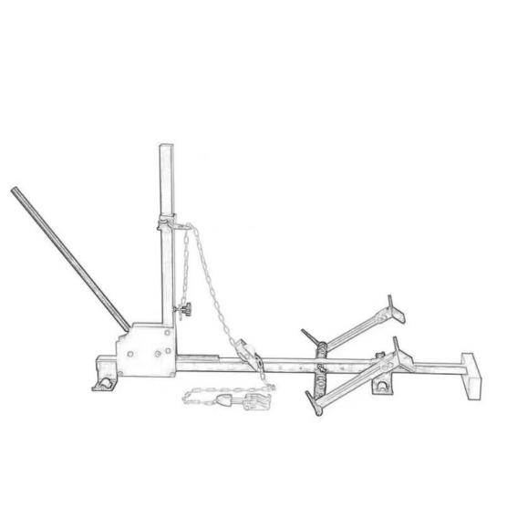
（Section III）
Equipment Name: Auto Body Sheet Metal Quick Repair Pull Tower
Equipment Model: Gear Rack Style Sheet Metal Pull Tower
Maximum Allowed Pull Force: 600KG
Applicable Vehicles: Sedans/SUVs/Minivans, etc.
Manufacturer: JiangSu Pioneer Sheet Metal Co., Ltd.

Product Overview：
This product is a three-in-one repair pull tower for auto body sheet metal maintenance, suitable for full-position body stretching and repair. It can output a pull force ranging from 0 to 6000KG during the sheet metal repair process, allowing for adjustable pull height, angle, and position, making body repairs more efficient, reducing repair time, and enhancing repair quality.。
Name | Quantity | Unit | Specification | Remarks
Pull Tower (including guide ring) | 1 | unit
Ground Anchor (including 4 expansion bolts) | 2（standard） | sets |  | Optional
Chain | 1 | piece | 1 ton bearing capacity
Single-eye Stainless Steel 304 Pull Claw | 1 | set | 6 claws
Single-eye Stainless Steel 304 Pull Claw | 1 | set | 8 claws
1.5m 6mm Chain Tightener | 1 | set |  | Optional
Skirt Support Rod (including regulator) | 1 | set
Tire Pressure Plate (front, side) | 1 | set
1.5m Safety Rope | 1 | set

1.The product is welded from 40×40×5mm thick-walled rectangular seamless pipes, offering high strength and able to withstand a maximum pull force of 600KG.
2．Used as a power output device during the sheet metal working stretching process.
3.Before using the product, customers need to install ground anchor seats at the sheet metal workstation.
4.Usage: Move the product to an appropriate position. Connect one end of the stretching chain to the tower column guide ring and the other end to the vehicle body (through sheet metal fixtures, pull claws). Secure one end of the chain in the opposite direction on the column, and connect the other end to the short chain on the ground anchor seat, forming a reaction force.
5.During the stretching process, the pull tower is not subjected to bending forces, ensuring a longer service life.
Operating Precautions:
1.Be sure to use the high-strength chain recommended by the manufacturer.
2..The stretching force should be less than the maximum allowed pull force specified by the manufacturer.
3.During operation, warn others to maintain a safe distance.
4.When stretching, operators must not stand in a straight line with the chain to prevent safety accidents caused by chain detachment.
5.Before stretching work, ensure the pull tower is securely and reliably fixed.
6.Before stretching, connect the sheet metal fixture, chain, and reliable safe positions on the vehicle body with a safety rope to prevent the chain and pulling tools from falling off and causing safety accidents.

Product Features:
1.The product is welded from 40×40×5mm thick-walled rectangular seamless pipes, offering high strength and able to withstand a maximum pull force of 600KG.
2．Used as a power output device during the sheet metal working stretching process.
3.Before using the product, customers need to install ground anchor seats at the sheet metal workstation.
4.Usage: Move the product to an appropriate position. Connect one end of the stretching chain to the tower column guide ring and the other end to the vehicle body (through sheet metal fixtures, pull claws). Secure one end of the chain in the opposite direction on the column, and connect the other end to the short chain on the ground anchor seat, forming a reaction force.
5.During the stretching process, the pull tower is not subjected to bending forces, ensuring a longer service life.

